Getting Started With xUnit.net

Using .Net Core With Visual Studio

**Create a xUnit Test Project**

**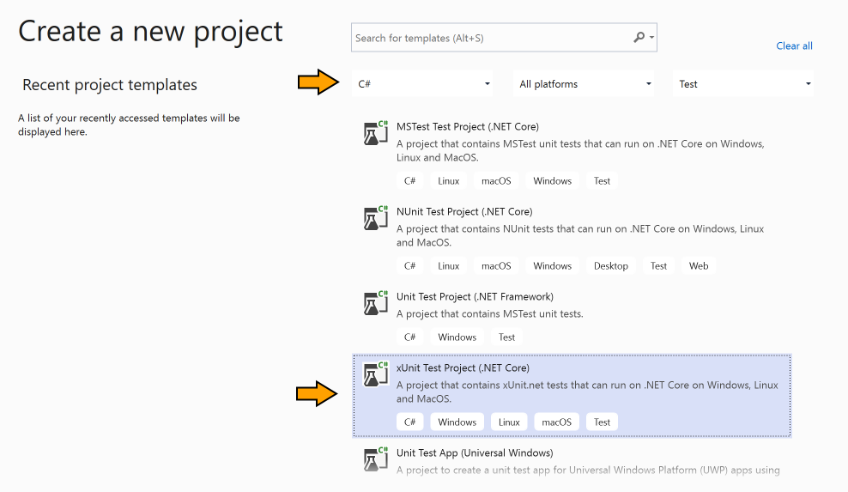**

**Why are Using xUnit?**

Besides the InlineData attribute, xUnit **provides you with other ways to define data for theories**, like  **ClassData , where the data source is a class implementing the IEnumerable interface, and MemberData , where the data source is a property or a method**.

**Why should I Use xUnit?**

**xUnit is far more flexible and extensible than the other .** **Net Unit test frameworks**. It allows you to create new attributes to control your tests

**what is the Xunit?**

xUnit is **the collective name for several unit testing frameworks that derive their structure and functionality from Smalltalk's SUnit**. SUnit, designed by Kent Beck in 1998, was written in a highly structured object-oriented style, which lent easily to contemporary languages such as Java and C#

🡺xUnit.net is **a free, open source, community-focused unit testing tool for the .** **NET Framework**. Written by the original inventor of NUnit v2, xUnit.net is the latest technology for unit testing C#

**How do I start xUnit?**

**Getting Started with xUnit.net**

1. Download the .NET SDK.
2. Download Mono (non-Windows machines)
3. Create the xunit test project.
4. Setting up a unit test MSBuild target.
5. Write your first tests.
6. Write your first theory.
7. Run tests with Text Exploer

**[Fact]** – attribute states that the method should be executed by the test runner

[**Theory**] – attribute implies that we are going to send some parameters to our testing code. So, it is similar to the [Fact] attribute, because it states that the method should be executed by the test runner, but additionally implies that we are going to send parameters to the test method

[**InlineData**] – attribute provides those parameters we are sending to the test method. If we are using the [Theory] attribute, we have to use the [InlineData] as well

**Create The xUnit Project**

**After Create Project we can**

**come like this**

****

**Why are Using Fact?**

We use xUnit Fact **when we have some criteria that always must be met, regardless of data** For example, when we test a controller's action to see if it's returning the correct view.

After We Run The Pogramma we Have Check Like This In Text Exploer

Errors will come like this

## **Write your first theory**

You may have wondered why your first unit tests use an attribute named [Fact] rather than one with a more traditional name like Test. xUnit.net includes support for two different major types of unit tests: facts and theories. When describing the difference between facts and theories, we like to say:

***Facts* are tests which are always true. They test invariant conditions.**

***Theories* are tests which are only true for a particular set of data.**

**We Can Create Theory this Like ?**

**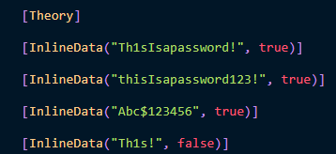**

**By using the**[Theory]**attribute, we are stating that we are going to provide some data to this test method as a parameter. Additionally, with the**[InlineData]**attribute, we are providing concrete data for the test method.**

**TL;DR:** This article will guide you in creating automated tests with xUnit for your C# applications. You will learn the basics of automated tests and how to create unit and integration tests.

Regarding the way to structure your automated tests, a typical approach follows the so-called [**AAA** pattern](http://wiki.c2.com/?ArrangeActAssert). The name comes from the initials of the three actions usually needed to perform a test:

* **Arrange**. With this action, you prepare all the required data and preconditions.-🡪**Set values**
* **Act**. This action performs the actual test.
* **Assert**. This final action checks if the expected result has occurred.-🡪 **Calling the arrange and act**

## Your First Unit Test with xUnit

The .NET Core platform supports different testing frameworks. However, [xUnit](https://xunit.net/" \t "_blank) has become the most popular due to its simplicity, expressiveness, and extensibility. The project is supported by the [.NET Foundation](https://dotnetfoundation.org/), and it is part of the more recent versions of .NET Core. This means that you don't need to install anything but the [.NET Core SDK](https://dotnet.microsoft.com/download).

We Have Run these Like Also

**We also run all test cases or individual tests within Visual Studio using Test Explore.**

